Empower Tower

Welcome to the Empower Tower challenge! This 5-week challenge will help you make healthful, well-balanced nutrition choices and improve your physical activity levels to empower your team to reach new heights.

How it Works
Each week, use your individual tracker to record your physical activity and nutrition activities to earn points. Everyone who returns their tracker on time and earns at least 20 points will be entered into a prize drawing each week to win prizes such as [Prizes].
Participate in activities with your teammates to earn additional bonus points each week. Get an average of 20 points or more each week so that your team can make it to the Sky Deck at the top of the tower by the end of the challenge. The first team to make it to the Sky Deck will earn the Sky Deck grand prize! All other teams who reach the Sky Deck by the end of the program will be entered for a grand prize!
Tracking
See the Week 1 Tracker (attached) for details on earning points. Turn in your Week 1 Tracker in to your Team Leader by [Date].
Prizes
- Weekly Winners: All participants meeting the 20 point/week goal will be entered into a prize drawing for a chance to win one of our great weekly [insert prizes].

- Sky Deck Winners: The team reaching the Sky Deck first will win a [insert prize] for everyone on their team. Note: The team must still participate for all 5 weeks.

- Grand Prize Winners: All other teams to make it to the Sky Deck by the end of the challenge will be entered into a final prize drawing for the chance to win a [insert prize] for everyone on their team.
Wrapping up
At the end of the challenge, continue making personal goals toward healthier living. To help us determine if Empower Tower helped you make healthy choices, please complete the evaluation and return to [Name] by [Date].

Empower Tower

Name: ______________________________ Team Name: ____________________________

Physical Activity Points
Check off one box for every 15 minutes of activity. 1 box = 1 point; Max = 15 points

1 | 2 | 3 | 4 | 5 | 6 | 7 | 8 | 9 | 10 | 11 | 12 | 13 | 14 | 15

Total Physical Activity Points: __________

Nutrition Activity Points
Check off one box for each day you complete the activity. All 4 days (boxes) = 1 point; Max = 8 points

- Avoid candy, sweets, and other desserts all day and replace them with healthy alternatives.
- Eat a healthy breakfast that includes at least one fruit or vegetable, protein, and whole grain.
- Bring a healthy lunch to work (use www.choosemyplate.gov as a guide) instead of eating out.
- Drink 8 glasses of water (1 glass = 8 ounces).
- Choose whole grains (brown/wild rice, whole grain bread, sweet potatoes, etc.) instead of white refined carbs (white rice, bread, pastries, etc.).
- Choose healthy (grilled, broiled, baked) proteins (fish, poultry, beans, legumes, nuts, etc.).
- Consume 5 servings of fruits/veggies each day (1 box = 1 day). 1 serving = ½ c. fresh, frozen or canned, 1 c. leafy greens, ¼ c. dried, ½ c. 100% juice.
- Avoid alcohol every day this week (1 point): ______

Total Nutrition Activity Points: __________
Bonus Points
Earn 1 point for each activity. Max of 3 points per week. You can only repeat the same activity twice. That is, if you always take the stairs, not the elevator, you can only use that option twice throughout the entire challenge.
Take a 10 minute walking break with co-workers at least 2 times this week.
Sit on an exercise ball instead of your office chair or your recliner at home.
Have a salad bar luncheon with your team this week.
Try a new fruit or vegetable this week.
Use a reusable water bottle all week and avoid using throw-away bottles.
Take a 5 minute stretching break at least 2 times this week.
Participate in a community-organized fitness event (Find local events at www.active.com).
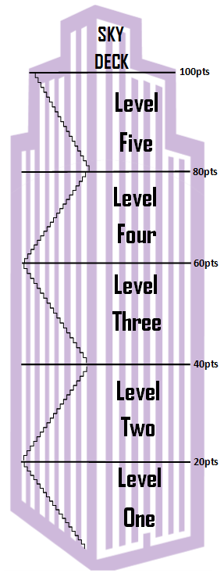
Have a fruit/veggie smoothie party with your team this week.
Do not drink soda (diet or regular) this week.
Walk or bike to work this week.
Do not eat out at a restaurant this week.
Bring a healthy snack for your coworkers this week.
Use the stairs instead of the elevator all week.
Use the stairs instead of the elevator all week.
Go for a walk with your family or friends this week.
Mix up your exercise routine with something different.
Have a fruit and yogurt parfait bar with your team this week.
Use a reusable water bottle all week and avoid using throw-away bottles.

Total Bonus Points: __________

Total Points for Week 1 (Physical Activity + Nutrition + Bonus): ___________

Earn 20 or more points this week to be entered for the individual weekly prize! Also, help your team average as many points as possible to reach the Sky Deck first to win a team prize! And all teams that reach the Sky Deck by the end of the challenge will be entered for a grand prize!

Submit your total points for Week 1 to your Team Leader by [Date].
Team Leaders: Submit your team’s totals to [Coordinator Name] by [Date].

